Colors Couture Guardian Application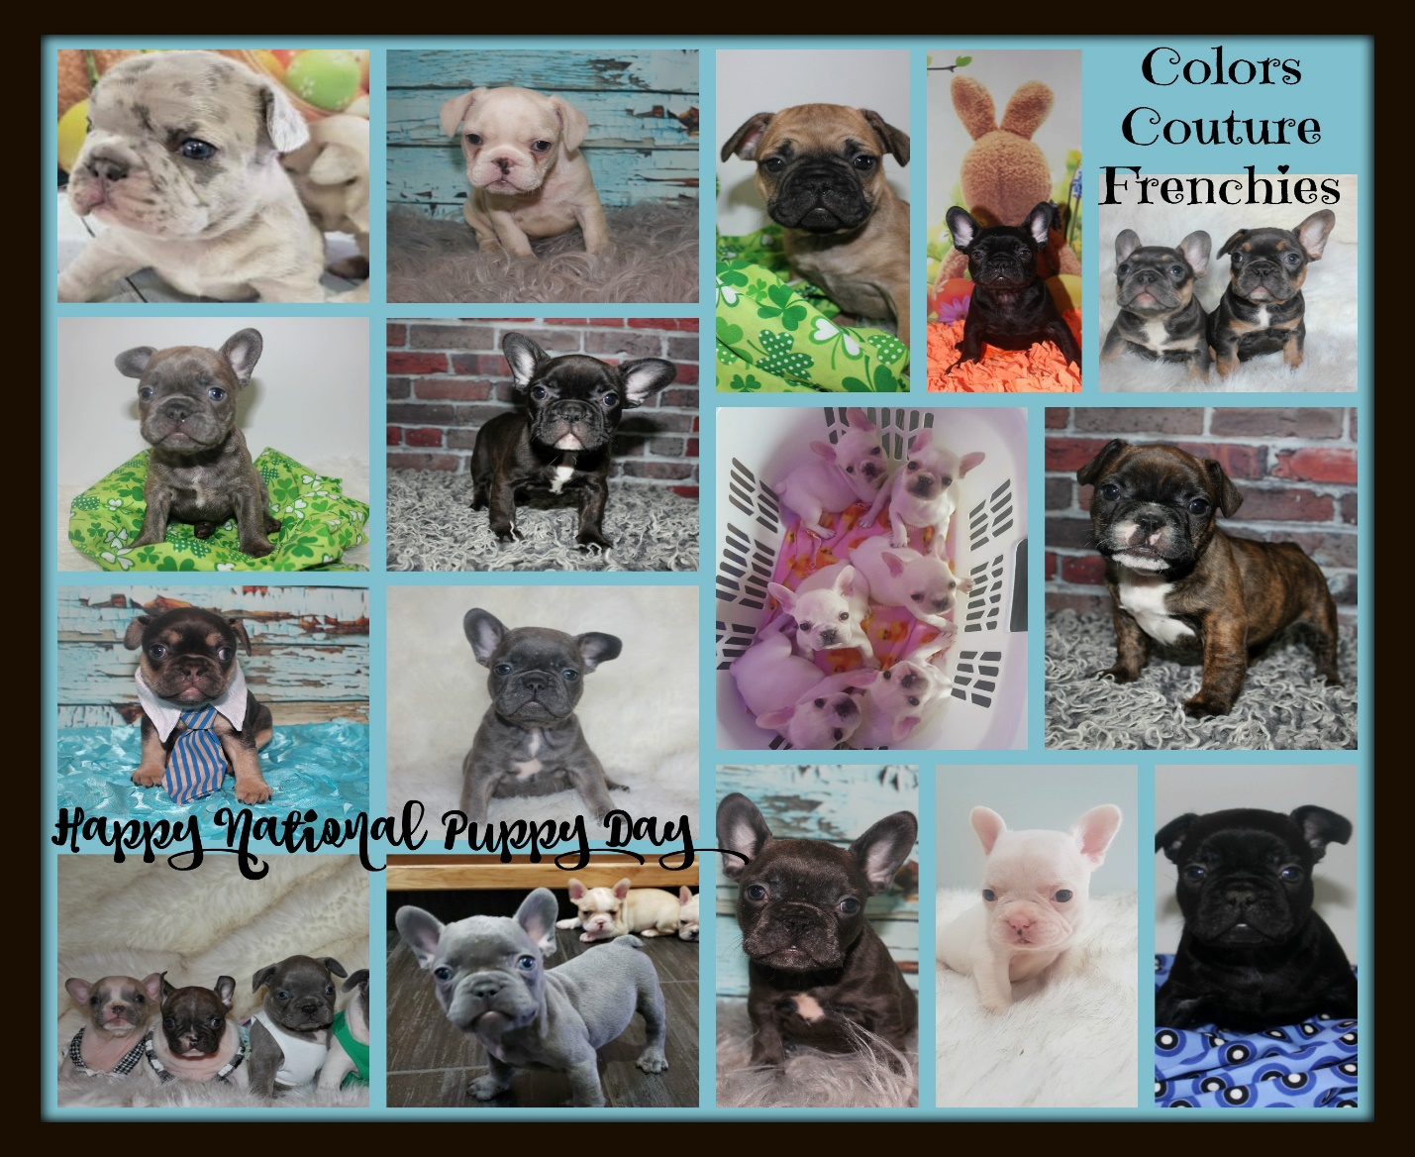
All fields marked with * must be filled out.

Full Name *

Email Address *

Phone Number *
Address *

City *

Province/State

Postal Zip Code

Country

Gender Preference *
Male
Female
No Preference

Color - First Choice *
Black
Fawn
Blue
Chocolate
White
Lilac
Merle
Blue & Tan

Color - Second Choice *
Black
Fawn
Blue
Chocolate
White
Lilac
Merle
Blue & Tan

Are you willing to take a pied puppy if its in the color of your choice.*
Yes No

Are you willing to take a puppy that does not match your stated preferences? *
Yes No
Is this your first dog? *
Yes No
Is this your first time raising a puppy? *
Yes No
What are your family's interests? *

Please tell us more about the house that you live in*

Do you Own or Rent*

Does your home have a fenced property? *

Yes No
Have you ever had to rehome an animal if so why ? *

Do you have other pets ? *

How many adults? *

How many children? List ages. *

If you have other animals in the house, are the neutered, and up to date on Vaccines? *

Who do you currently use for a Vet? *
Does anyone in the home have allergies? *

Where will puppy spend most of its time? *

Average time your puppy will be home alone each day? *

How will your puppy be trained? Will you be willing to crate train your puppy? *

Why do you want to be a Guardian home with us, and what does being a Guardian home mean to you? *

Comments / Questions or other information that would help me in choosing a puppy for you.

2 Reference Check *

Please state a reference including first and last name, email, phone number

